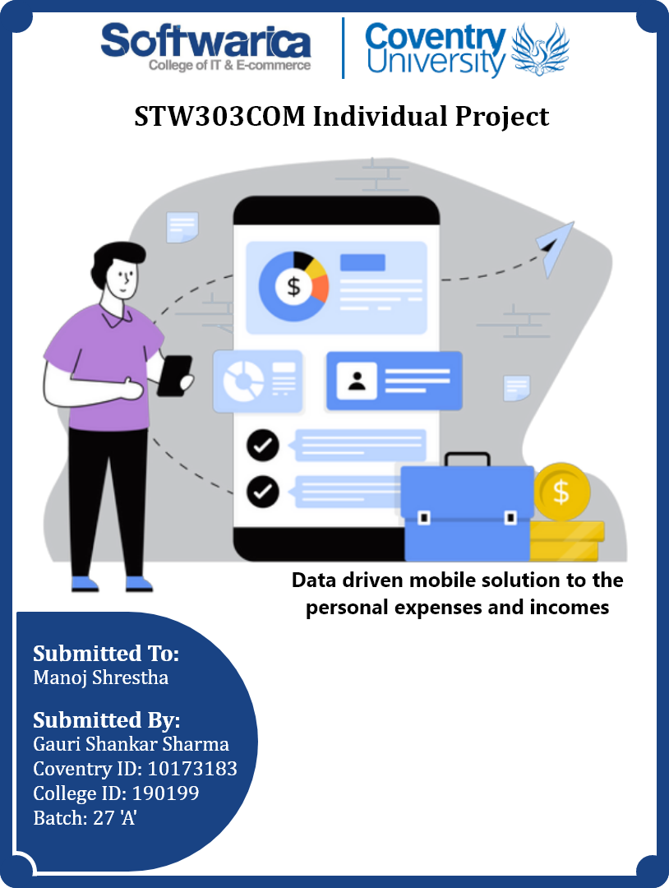

**Keywords**

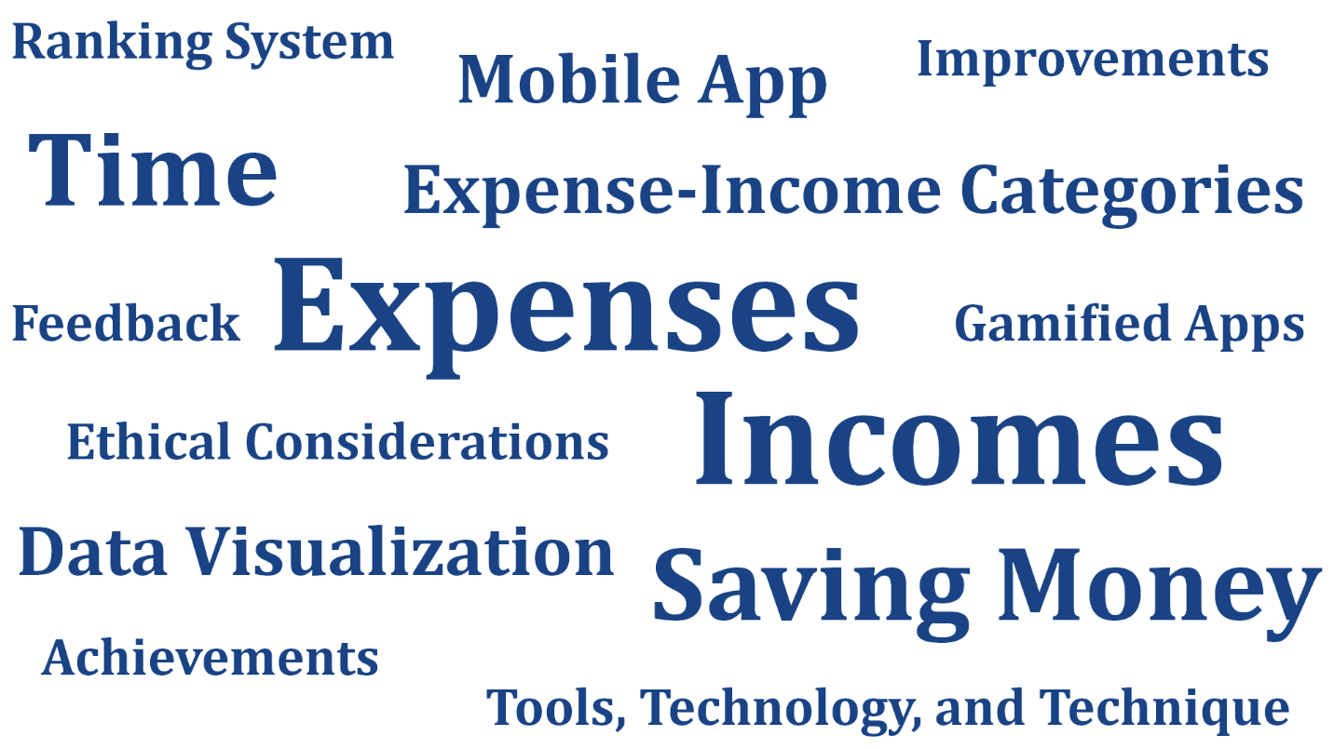

Figure 1: Keywords for this dissertation

**Table of Contents**

**Introduction** 1

**Aim** 2

**Objectives** 2

**Justification** 3

**Research Questions** 5

**Scope** 5

**Ethical Consideration** 6

**Literature Review** 7

**Desk based research** 7

**Stack Overflow** 8

**PUBG Mobile** 9

**Nike Run Club** 12

**Development Methodology** 13

**Tools, technology, and techniques** 15

**Bibliography** 17

**Table of Figures**

Figure 1: Personal Economic status 1

Figure 2: Solution to untracked expenses and incomes 3

Figure 3: Scope of this project 5

Figure 4: Ethical Consideration of this project 6

Figure 1: Stack overflow website 7

Figure 2: PUBG Mobile 9

Figure 3: Nike Run Club 11

Figure 1: Agile with Scrum methodology 13

# **Introduction**

Personal expenditures might differ from small amounts to huge amounts depending on how a person might spend money daily. These expenses are rigid, changeable, and unexpected. Rent can be taken as a rigid expense because the money spent on the rent is fixed and doesn’t get changed with time. On the other hand, the expense which changes with time is changeable expenses for example electric bills and groceries. Unexpected expenses are those which occur without a plan and it does not concern time. Repairing a car’s broken parts or visiting a doctor is an unexpected expense. Similarly, the incomes of a person also differ from small to huge amounts depending on how a person works and they might be fixed or changeable, or occasional (Siyavula, 2022). Only rare people keep notes of their expenses and incomes to take better care of their money. But those who don’t do it will not have any idea about how much money they are spending daily or weekly or monthly, what are things they are spending money on, where to avoid spending money, what are the other income sources apart from the salary or wage. Because of this, there might be a high chance of running out of money. It will be hard to take a good economic decision while running on low money.

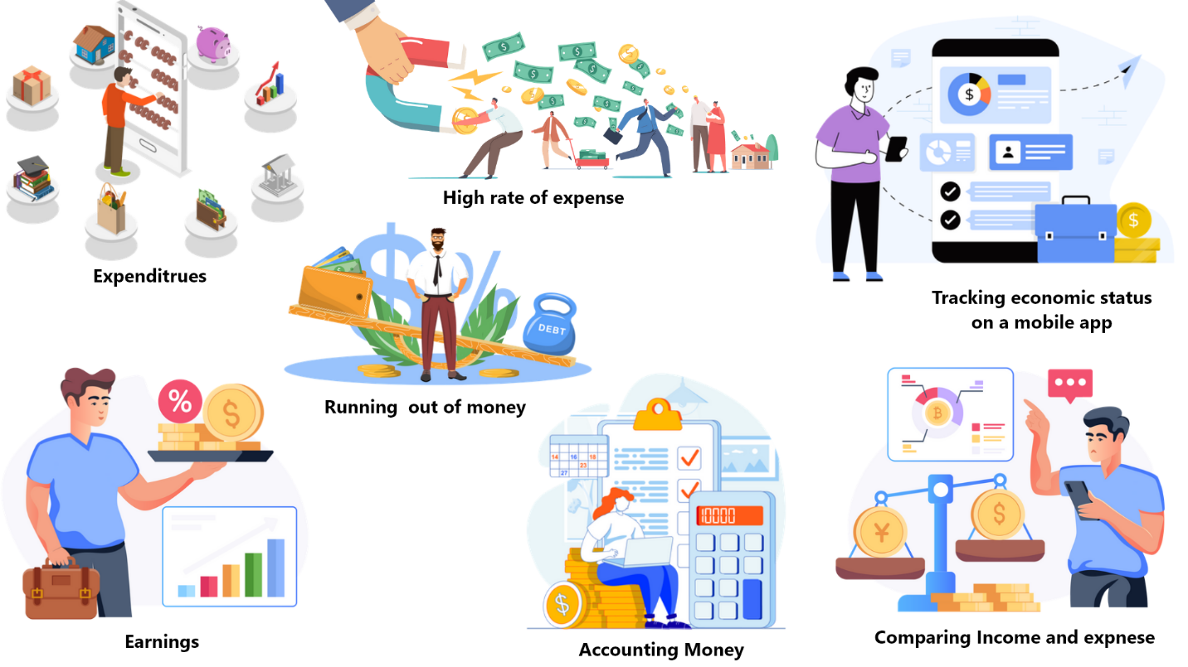

Figure 2: Personal Economic status

Sometimes people spend too much money and get into debt. Managing money very carefully and planning activities can reduce expenses and increase savings. In the same way, saving money will be beneficial while paying for unexpected expenses for example health problems. Therefore, monitoring expenses and incomes monthly is very important and this will help to decide which expenses are low and high priority. Let’s consider a person has been left with a little amount of money during the last days of a month, then food will be important rather than buying ornaments or watching movies. To monitor the expenses and incomes, written papers or a text file will not be enough or a better solution. A system that can keep records of all expenses and incomes permanently is required in this situation. A mobile app will be better because it will be easier and more flexible for people. Likewise, users also should be able to visualize their daily, weekly, and monthly expenses and incomes in different ways with the app. The app should also give feedback if the user manages the expenses well or not for making better economic decisions. Similarly, giving points, and achievements to the users, if they do well, then they will be encouraged and motivated to do better in the future. Making a competitive environment will be more entertaining for the users to use the app and not get bored. These are gamified content of the app to keep the users attracted. This kind of gamified content could be also seen in other non-gaming apps like the Nike Run Club and Stack Overflow website, etc. In this way, a person can handle all expenses and income status in the hand with a mobile app and get rid of personal financial problems.

## **Aim**

Provide a data-driven mobile solution to the personal expense and income status for making better individual economic decisions.

## **Objectives**

* Research on expenses and incomes
* Researching the existing systems and understanding the workflow
* Self-researching for making more better system than the existing one
* Challenges findings for the system
* Use the appropriate methodology, tools, and technology to develop the system
* Documentation and report submission

# **Justification**

Most people don’t keep records of how much money they are spending and earning. Sometimes people spend money on unnecessary things knowingly or unknowingly and the expense becomes greater than the income which might arise financial problems. They don’t know what fields they are spending money on, or which field they have spent money on most or less. Likewise, categorizing their expenses like Food, Education, Health, Transportation, Clothing, etc. could help to manage expenses properly. But many people don’t do that. Not keeping in mind their expenses and how much money is left could lead to such kind of financial problems. However, no one wants to spend money on unnecessary activities or things but it is hard to find those things without any kind of references. Those who have a tight budget and have to look after lots of things over a fixed time definitely should keep track of their expenses and income otherwise, they can run out of money. In the same way, people also don’t keep records of their income too. They don’t know what are their income sources and from which source they are earning the most or less. Categorizing their incomes could provide a better vision of their finance. Another thing that is very hard to know about expenses or incomes is the date. People might remember their expenses or incomes but they forgot when they have spent or earned that money but the date is also a very important thing. It will know the amount of money earned or spent on a date if the date of the income or expenses is recorded. Therefore, if people can keep a record of how much money they are spending, where they are spending most, how much they are earning, where they are earning most when they have spent or earned, and look back to their income and expense history, then they will get an idea about how to handle their economic status and where to avoid spending money in the incoming days. Similarly, being careful and informed is the most important thing for better economic decisions rather than facing the problem, realizing what was the mistake, and then understanding what should be done next time.

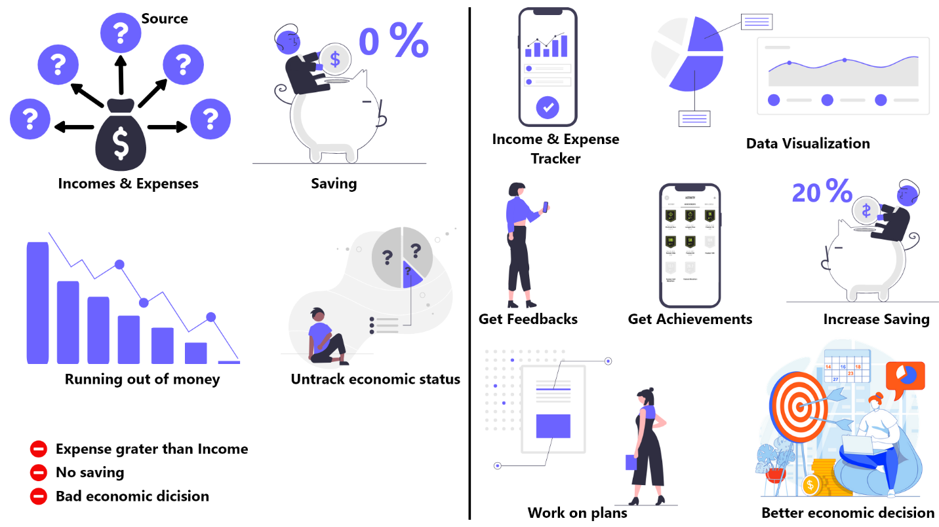

Figure 3: Solution to untracked expenses and incomes

A mobile app will be best suited for this solution because writing all the incomes and expenses in a textbook, or a text file will be time-consuming and bothering. If the textbook is lost or the text file is deleted, then it will be game over. On the other hand, people might use an excel sheet to keep records of their expenses and income sources. But it will not be as much flexible as the mobile app while visualizing the data in many different ways. As the finance are personal, people will prefer using a mobile app instead of a website because a mobile app is easy to access, portable, more personalized, and even could be operated offline. Websites are better responsive to computers than mobile apps due to the variable screen size of the mobiles. Users can add their expenses and incomes as much as they want on a day in the app. The app will save all the expenses and incomes of a user and give feedback if they are doing well or not. Users can access their data anytime wherever they want and their inserted data will be never lost even though they uninstall the app because all the data will be saved in the cloud. They can access their expenses and incomes based on the current day, week, or month, or manually selecting the day or according to the expense and income category. Similarly, they will get progress points and even can unlock achievements according to how much data they insert, how regularly they insert data into the system, and how well they will save money in a month. The more they insert data into the system the more they will get progress points and unlocking achievements will give even more progress points. This will motivate and encourage them to keep using the app more and more. All the achievements will be calculated for a month and the next month, users have to score again. But the progress point won’t be lost. Likewise, users can share their progress points and users with the high progress point will be listed on the ranking system. But the sharing of progress data with the public will be optional for the users. This will provide a healthy competitive environment and users will be attracted to the app continuously. The app will answer the when, where, how much, and for what questions of their both incomes and expenses. This will help users to have better control and make better decisions about their expenses and incomes because they will start working on plans. Similarly, they will avoid unnecessary spending, save money as much as possible, know the area where they are spending money most and less, and the high earning sources.

# **Research Questions**

* What kind of income and expenses do people have?
* How can be people encouraged to track their expenses, and incomes and save money?
* What are the ethical considerations while storing users’ expense and income data?

# **Scope**

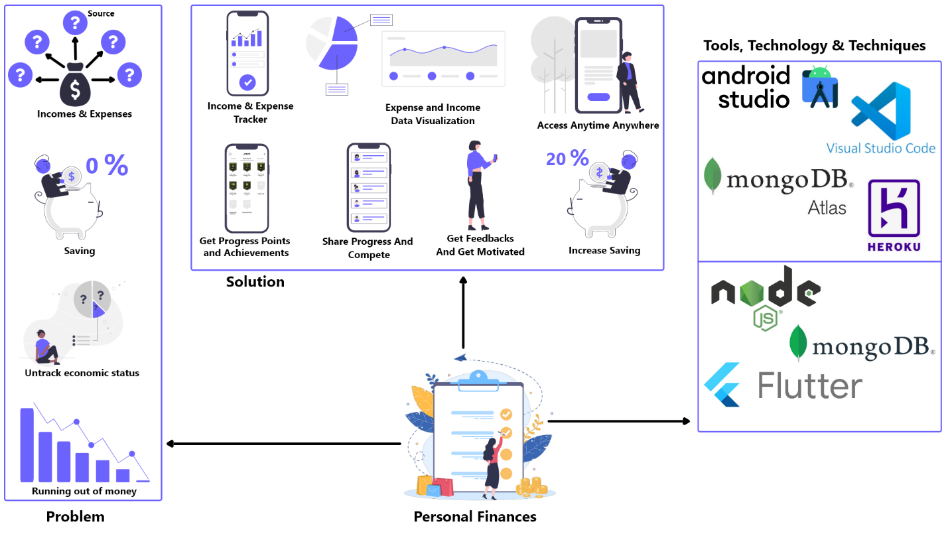

Figure 4: Scope of this project

# **Ethical Consideration**

During the research and development process of this project, any harm that could happen to individuals has been completely avoided. The resources that are used in this project have been properly cited to the respective owners. Users of the Expense Tracker app generate lots of data related to their expenses and incomes but this data has not been shared with anyone else, not even with the other users of the app, and also not used for any other purposes. These data are saved permanently in the cloud and the users can see only their data. Users’ password gets expired after two months and they must have to change the password to use the app. Likewise, the app provides a ranked system where users with high progress points are listed. These data are also shown according to the user’s permission. There is an option for sharing progress points or not on the setting page and only those users who have shared their progress points are shown in the ranked system. All the tools and technology used in this project are open source and legal to use. No cracked version of tools or technology is used. The source code of the app is also developed from scratch, not copied from the internet. No copyright content is used in this project.

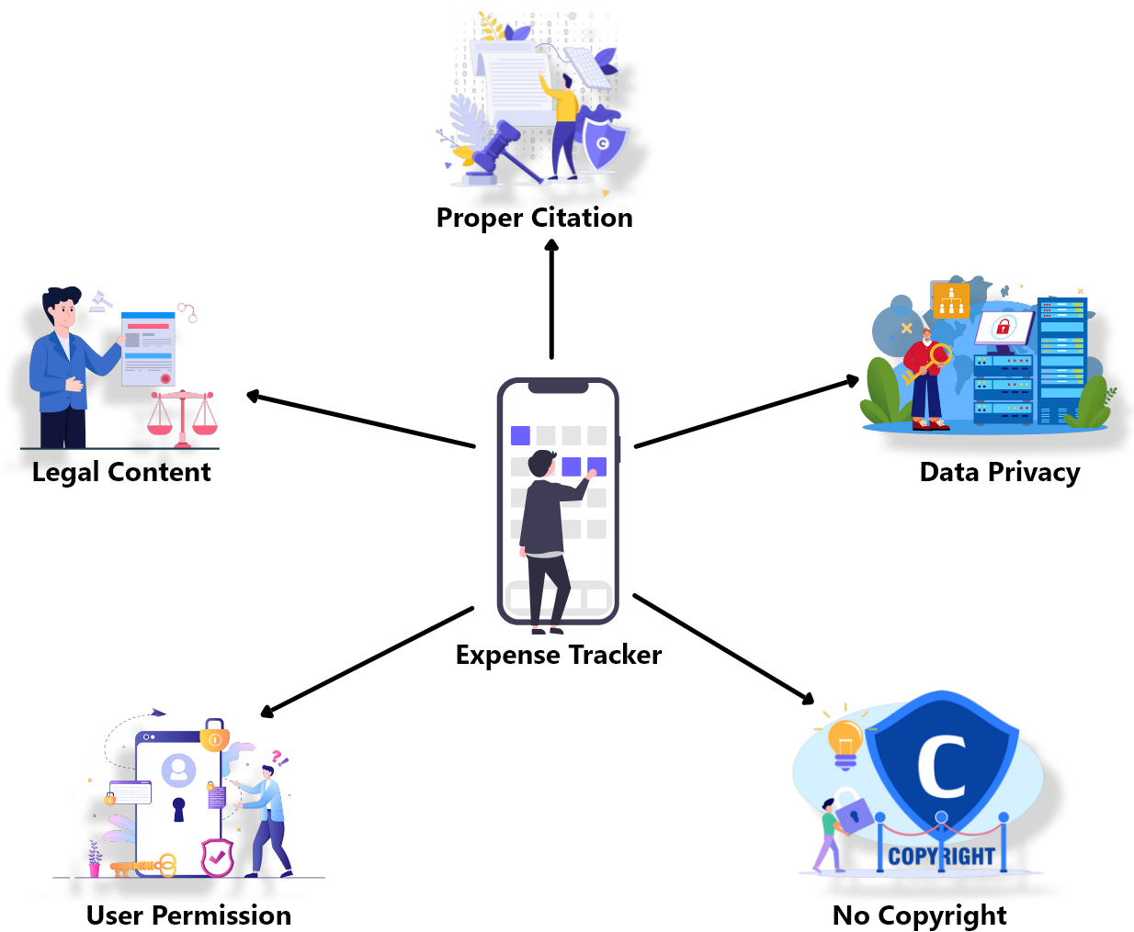

Figure 5: Ethical Consideration of this project

# **Literature Review**

## **Desk based research**

Desk-based research is a secondary research method that is used in this project. It is more cost-effective, less time-consuming, and popular, as it uses already available public data and information unlike primary research which generates new data and information and that requires a large amount of money (QuestionPro, 2022). In the same way, the data and information required for this project were collected from already existing sources like books, websites, past research papers, articles, etc. All the collected information was cost-free. After searching and going through multiple results, most of the research which were from authentic sources. The research was done before actually developing the system. Then the collected information was organized in a sensible order and the main outcome of the research was also identified. This research gave a clear understanding and a better idea of the research topic. Desk-based research is very faster because it uses available data but does not need to collect data from scratch which also reduces cost. Similarly, it also provides an idea of the primary research’s effectiveness. On the contrary, sometimes it becomes hard to find the latest information and data while doing desk-based research.

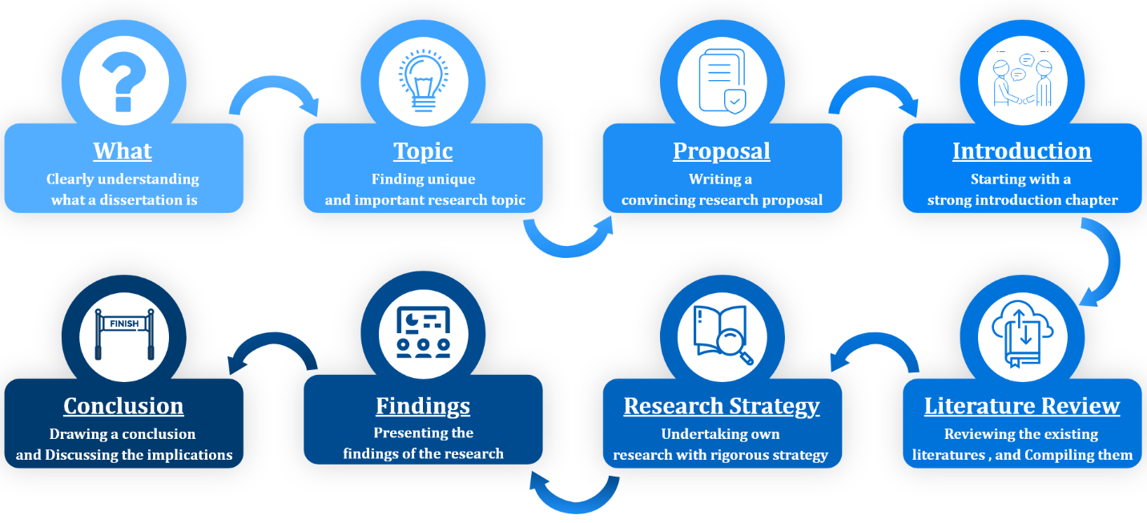

Figure 6: Processes involved while writing dissertation

## **Stack Overflow**

Stack Overflow is one of the world’s biggest technical questions answering site. It helps enthusiastic software developers solve their problems. Quora, Wikipedia, and YouTube are also user-generated content websites but finding the solution to a particular question might be time-consuming on those sites (Nir Eyal, 2014). On the other hand, Stack overflow solves these problems easily. Users can ask practical and detailed questions, as well as get the right answer without any distractions. The provided answers are specific, might be highly technical, and do not contain any discussion forum. Similarly, tagging questions with their subject areas makes it easier to find the interesting and right questions. It saves a programmer’s time while finding the solution to a problem but it will not be the same on other sites (Overflow, 2022). It contains 21+ million questions and helps 100 million people per month (Overflow, 2022). People spend so much time answering the questions of others on the site but what people get from it while using it, and what motivates them to continue using it are some interesting things to know about.

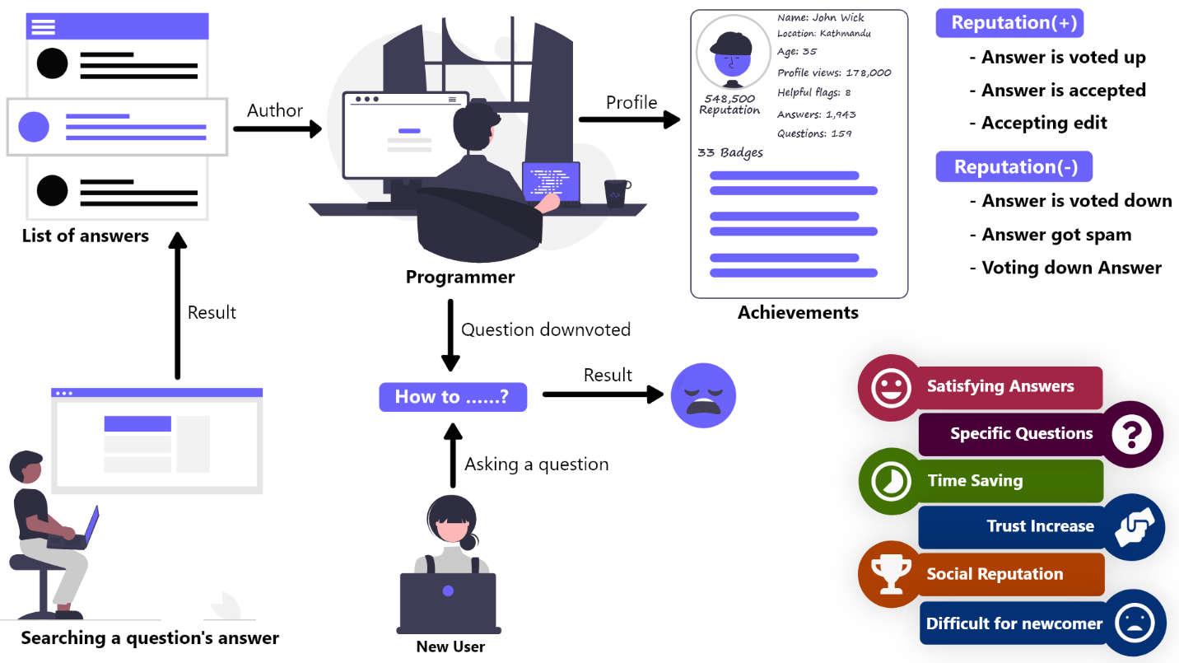

Figure 7: Stack overflow website

The site provides rewards to the ones who provide answers to the questions. In the same way, other users can respond to the answers and questions by giving an upvote or downvote and the most upvoted answers are infiltrated upwards. From these votes, the author of the answer also gets points and after reaching a certain point, the author earns badges which are satisfying and this makes them feel like they are at a special status and privilege. However, how many points and badges an author gets after responding to the questions is unclear and highly variable. On this site, points and badges are not just game mechanism but also represents how much a person has contributed to the community. It provides a platform for software engineers to enjoy helping other programmers and get disserving respect as well as satisfaction from the community which is a game-like experience (Nir Eyal, 2014).

A user can gain or lose reputation points according to the response of other users to that user’s work. When a question, answer, or article is voted up or an answer is marked as accepted or accepting a suggested edit, reputation points are gained. However, there is a limitation on the reputation points gained per day from up and downvotes and suggested edits. Conversely, reputation point is loosed if the question, answer, or article is voted down or on voting down the answer, article of other users, or if a post has 6 spam flags. The starting reputation point for all the users is one and never gets down below it. Reputation points cannot be increased by accepting own answer but there is no effect on the reputation points on deleting a post. Reversing a vote will also reverse the reputation point that was gained or loosed (Overflow, 2022). Users can achieve three levels of badges which are bronze, silver, and gold. Badges can be also earned by just reading the page too (Overflow, 2022).

New users find it difficult to participate in the stack overflow community since they are overwhelmed with down and close votes. Their questions must also go through a "First Post" review queue; otherwise, the questions will not be visible to the public. However, the most typical cause for a downvote is that expert programmers believe the question is too simple. It will be good for newcomers if the programmers ignore rather than downvote the questions. If the question box is redesigned with a paginated workflow, new users will be more likely to fill out all of the essential information. Many users do not receive the assistance they desire since their queries are not answered due to the lack of a method for retrieving and re-posting prior questions. Similarly, many inquiries on the web have no upvoted or acceptable replies (Gaiser, 2020).

The reputation system has played a big role in the success of the Stack Overflow website. If there was no reputation system on the website, then it would be boring and worthless answering the questions because the contribution of a user could not be evaluated which is dissatisfaction. And because of this, there would be fewer users answering the questions. Likewise, users would have a difficult time finding the right and satisfying answer. Due to this, the site would not have as many users as it has at the current moment. This proves that introducing gamification in a system provides a better as well as more satisfying user experience.

## **PUBG Mobile**

PUBG Mobile is a very popular game on the mobile platform. It has highly gamified content which gives a better and highly satisfying user experience than normal mobile games due to which gamers are addicted to it. In 2020, it has generated $2.6 billion in revenue and become the world’s highest-grossing game (Curry, 2022). It is a free-to-play battle royal game. A battle royal game is a multiplayer game involving a large number of players who control their character and parachute onto a virtual map with a shrinking zone where they will have to collect loots, fight with each other and survive until only one person is left (Staff, 2022). But it has more interesting content like ranking system, Points and Coupons, inventory management, royal pass, create opening, events, banning system, new UI, and updates compared to a normal battle royal game. Similarly, it has a realistic gaming environment. The guns, areas, and fight mechanisms match with the real world. In the same way, some of its features like shooting mechanics, character movements, map variety, vehicle variety, match mode variety, and entertaining looting alternative to fighting make it unique and better than other battle royal games (Haley, 2021).

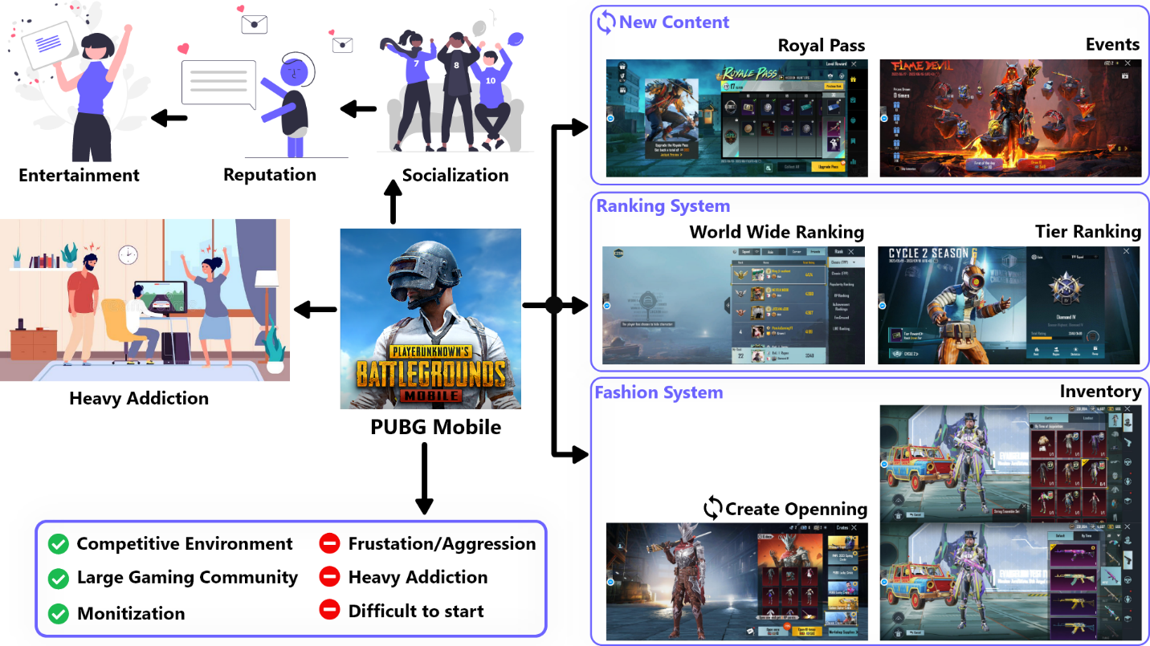

Figure 8: PUBG Mobile

Players can earn and lose points from battle royal matches and these points are used to rank up the player’s tier (badge). Bronze, Silver, Gold, Platinum, Diamond, Crown, Ace, Ace Master, Ace Dominator, and conqueror are the tier levels from lower to higher (Rai, 2022). Earning points from matches becomes harder after reaching a higher tier or players can lose points if they don’t perform well. However, players’ tier is reset to a lower level after each season and they have to again level up it. Players can look at their match history, the performance status of each match, and each season's total kills, KD (Kill/Death Ratio), surviving time, the number of matches played, or current rank among friends and worldwide based on Achievement Points, KD, Surviving Time, Popularity Points, Royal Pass points. Likewise, unlocking the achievements can give achievement points, equipment ‘s skins, and emotes along with BP, Silver, AG coins, and coupons which are used to purchase items in the shop. Spending UC on events, players might also get some or all UC back. UC is the most expensive and valuable currency in the game which is also used to purchase items in the shop. On the other hand, players can add friends and play a match in solo or dual, or squad mode too. Different maps and various types of match modes give players flexibility and different flavors of gaming experience. Players can visit others' profiles and check out their skill, season status, inventory, and achievements, send gifts and popularity points, as well as play a custom match with them.

Inventory is one of the most attractive parts of the game. Players can view their cloth, gun, vehicle, helmet, bags, parachute skins, emotes, stickers, coupons, redeem points, and redeem cards. Similarly, they can get skins, coupons, and emotes by spending UC, Silver Points, AG Points, and BP Points from the shop or by redeeming them in the events. They can play matching wearing any cloth skins, applying any gun and vehicle skins. They can open creates with UC but money is required to buy UC. The most common creates are premium, classic, supply, and soldier creates. On the other hand, these crates can be opened without UC too but it requires coupons, AG, or BP currency. Likewise, Players can get new guns, vehicles, clothes skins, emotes, coupons, Silver, AG, BP currency, stickers, etc. after opening creates. These things can be achieved from events too after completing the event missions. They can earn titles, avatar frames, and equipment skins from events and achievements. Some of them are unique and rare. In the same way, the game also offers upgradable skin for guns, clothes, and vehicles but they have to spend lots of UC to fully upgrade them. These skins are very attractive and only rich players have these skins. They can show up their inventory items in the lobby as well as inside the match. Inventory can be regarded as the fashion system.

New updates are provided time-to-time so that the players can have a new and exciting gaming experience and they won’t get bored. Nowadays, New seasons are launched every two months, and an application update before each season. Players can experience new features and UI design after each application update. Similarly, new seasons bring new events inside the matches so that players can explore new areas. A new Royal Pass is also launched every month which contains cloth, guns, vehicle skins, emotes, coupons, silver points, BP points, AG points, stickers, popularities points, etc. Each Royal Pass contains a free and elite version of it. On the other hand, players get limited and low-quality items in the free version. However, they can also spend UC to get an elite royal pass that contains high-quality items. They can report other players or teammates who break the rules like cheating, use of vulgar language, and killing teammates. The reported players can get banned from the game for a certain time or lifetime according to their actions. This makes gameplay very fair and all players want this. Some guidance and free gear are also provided to the newly joined players so that they can taste the game more easily and quickly involved in its gaming community.

Pushing rank is very difficult and frustrating. Players have to give lots of dedication and time to be listed as one of the number one players but it will give the player just an online reputation only. PUBG mobile is difficult to play and requires high skill to get the full fun in the matches. Moreover, the recoil system of the guns and too many buttons to control the character make the gameplay difficult for beginners. In the same way, new players are eaten by the well-skilled players in the matches and most of them quit playing the game because of this. Matching low-skilled players with other low-skilled players would be better for beginners. Sometimes new updates also bring bugs and glitches which make the gaming experience bad. Some gamers become heavily addicted to this game. Due to this, players suffer from physical and mental health issues, sleeping disorders, violent languages, aggressive behavior, poor academic performance, social distancing, and anxiety (JUSTZAYNED, 2021). Similarly, players also start spending money on Royal Passes, create openings, and other fancy things.

Players who have lots of items in inventory, high-quality gears, Royal Pass, and high skill are regarded as “pro” players, get respect, and hold high-level status in the PUBG mobile gaming community. Those who don’t have these things are regarded as “bot” players or beginners. Some of the players spend more time on opening creates, participating in events, and purchasing Royal Pass to have a high level of inventory rather than playing matches. PUBG Mobile provides an intense and competitive gaming environment with a ranking and fashion system among gamers. The introduction of new content brings excitement among players so that players never will be bored playing.

## **Nike Run Club**

Most people who love exercise and training cannot continue the training for a long time due to a lack of motivation. People get bored having consistent training or even fail to start without any form of encouragement or a personal trainer or a running partner because they don’t get any enjoyment. This kind of motivation gap is overcome by the Nike Run Club app by encouraging people in many different ways with the help of a gamified approach. This app features custom coaching plans, GPS, tracking, guided running workouts, motivation from other users and friends, and celebrating progress with congratulation messages and achievement titles which are fun to do. In the same way, users are also continually encouraged to report their runs and participate in organized challenges with other runners using the app. Many of the challenges are presented as colorful full-screen modals with awards for those who complete them. However, each challenge is only available for a limited period, giving hesitant users an added push to commit.

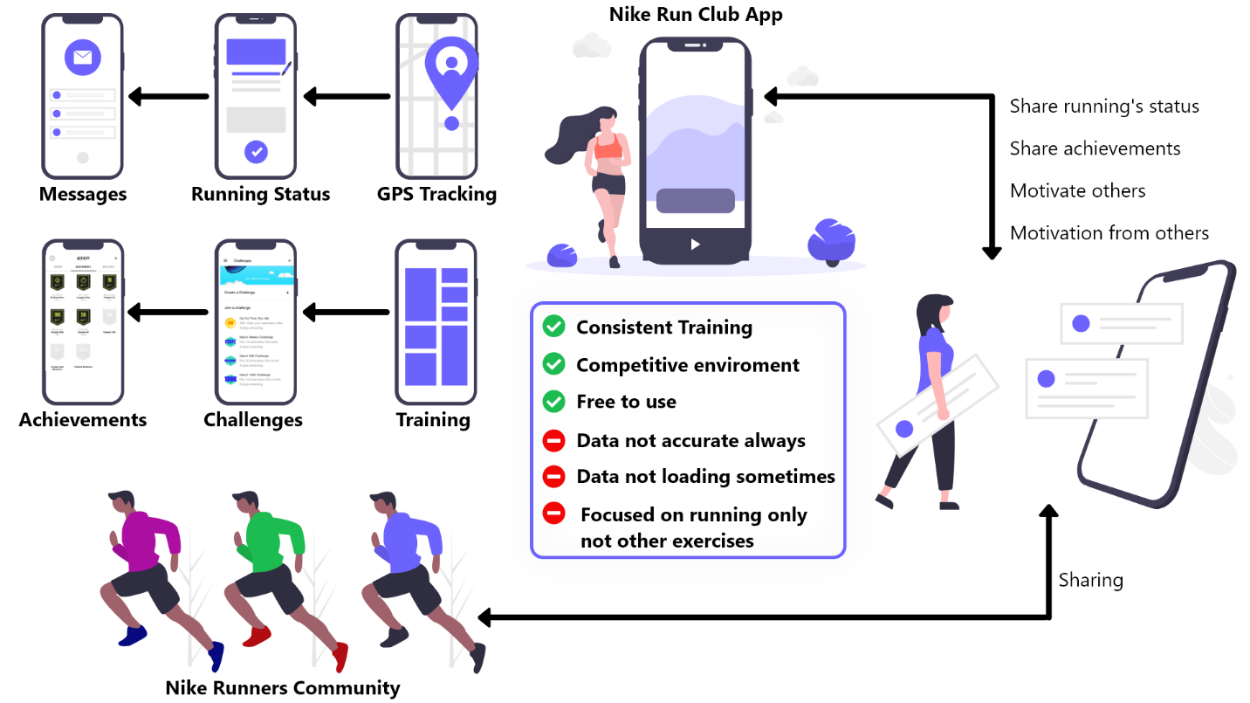

Figure 9: Nike Run Club

Keeping users motivated after the initial enthusiasm for a new app wears off can be difficult. But celebrating accomplishments is a great approach to keep users engaged throughout and after their first onboarding. Nike frequently recognizes modest victories by sending tailored messages praising users on their achievements and urging them to keep on moving. The constant encouragement increases users' confidence in their abilities while simultaneously increasing app engagement. And with each run, you'll unlock new achievements that you can share with your friends and improve over time. Likewise, users can also share their achievements with their friends instantly. A retention hook is a built-in feature that gives users a cause to send notifications to other users, which encourages them to return to the app. Of course, Nike doesn't generate money by making free apps. They make money by selling shoes and other athletic gear. As a result, the app includes an upsell prompt for Nike running items, which integrates online purchasing directly into the program and regularly tempts users to buy additional Nike products. The user's profile and running style are used to personalize product recommendations. Users can even track miles on their existing pairs of running shoes and receive automatic reminders when it's time to replace them.

But this app also has challenges like the provided data of the running is not always accurate, sometimes runs do not sync, do not provide any difficulty level indication of each run, and facing disruptive glitches (Jones, 2021). Similarly, GPS accuracy gets extremely poor and sometimes the challenges become very hard to complete like 100 miles a day (Harry, 2022). The app is not provided in all countries and will not work properly. However, people from all around the world who love to run and want to try this app but could not able to take advantage of it. It has training plans and coaching for running only but does not focus on other exercises related to yoga and gym otherwise people who love to do yoga or gym rather than running would also use it.

One of the app's values propositions is to improve and maintain motivation, which Nike achieves with time-limited and well-organized challenges, as well as by consistently recognizing users' accomplishments. Power users may purchase Nike fitness gear directly from the app due to integrated e-commerce features. Retention hooks motivate lazy users to come back to the app while also boosting the motivation of active users. This app makes people who are lazy or don’t have any encouragement to be a better version of themselves with the help of gamified content (ReallyGoodUX, 2022). Similarly, the app allows any runners the opportunity to join its community of runners, analyze personal running statics, participate in the personalized program for training according to personal objectives and level, share race statics with other users and friends, and win badges and trophies by participating in challenges. All of these are gamified features for the users to have a competitive and entertaining mechanism. The goal of this app is not just to bring users’ interests toward the Nike brand but also to spread and improve the Nike brand’s image in the sports community (Leclercq, 2015).

## **Development Methodology**

The project was developed using agile methodology. Agile can be regarded as a mindset or culture. Unlike traditional methodologies, agile methodology divides a project into different phases and uses an iterative and incremental approach to complete them along with constant customer collaboration and continuous improvements at every iteration. The sequence of project phases like analysis, design, development, testing, and deployment in an iterative way rather than a linear way is the main difference between agile and traditional software development methodology. Scrum framework is mostly used agile approach in software development and it was used in this project also. The development was started with a requirement analysis. Zero-sprint planning was done before starting the sprints where requirements were divided into user stories and all the user stories were given story points according to how difficult the user story might be. Easy user stories contain low story points whereas hard user stories contain high story points. Then they were categorized into epics, set high, medium, and low priority, and assigned to the product backlog in the storyboard. Then the higher priority user stories were brought into the sprint backlog in the sprint planning before starting a sprint. Low priority user stories were not brought to the sprint backlog unless all the higher user stories were completed. A sprint lasted one week and it was mandatory to complete all the brought user stories during that time. From analysis to deployment, all phases were done in a sprint. However, the amount of user stories that are brought to the sprint backlog depends on the velocity of the developers. Velocity refers to the amount of work that can be completed in a sprint. In the end, the completed works were moved to the Done section in the storyboard to review them. On the other hand, if there is any task left to be completed or requires some modification then it will be completed or modified in the next sprint. Similarly, the user stories were again brought to the sprint backlog from the product backlog for the next sprint in the sprint planning. The sprint was repeated until all the user stories were completed (Team, 2018) (Peek, 2021).

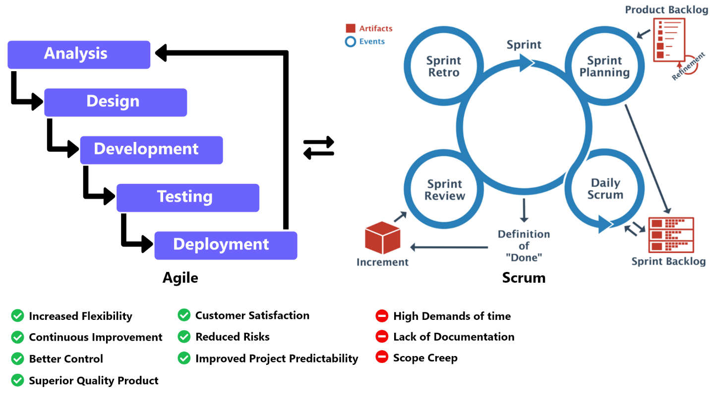

Figure 10: Agile with Scrum methodology

In traditional methodology, Limited customer involvement results in poor customer satisfaction, and documentation consumes more time rather than spending time on product delivery. Once the requirements are defined, then those cannot be changed or modified. This all results in a low-quality product (Team, 2018). This methodology is best for those projects whose requirements are rigid and well understood. On the other hand, Agile continuous delivery, continuous improvement, and continuous collaboration over every iteration increase flexibility and improve project predictability. It fulfills the main drawback of the traditional methodology by accepting changes and modifications at any time. In the same way, it also provides better control of the project due to which project risks are highly minimized. Customer collaboration increases customer satisfaction. Continuous improvement and customer satisfaction increase product quality at a high rate (Kissflow, 2021). The agile methodology also has some downsides like lack of documentation, continuous collaboration is difficult to maintain, and lack of processes easily sidetracks teams. The agile methodology does not match with a long-term process like building a house that has a fixed delivery (Wrike, 2022).

## **Tools, technology, and techniques**

The Expense Tracker app has been designed and developed using Android Studio, Visual Studio Code, MongoDB Atlas, and Cloudinary, and hosted on Heroku which is a Platform as a Service free cloud platform. During the development period, the Stack Overflow website was visited so many times for code solutions and to solve errors. MS Word, Adobe XD, and Team Gantt were used to generate content for the documentation part. Flutter along with Dart programming language is the major technology that was used in this project. Flutter was used to design the application interface whereas NodeJS was used to develop the backend. Lots of libraries were used to develop both the frontend and backend of the Expense Tracker application. In the same way, Adobe XD was used most of the time for designing logos and images for both the development and documentation part.

To design the backend part, node packages like “express”, “express-async-handler”, “mongoose”, “jsonwebtoken”, “multer”, “multer-storage-cloudinary”, “bcryptjs”, “nodemailer”, “cors”, “dotenv”, “nodemon”, and “validator” were used. “express” was used to create routers and run the server in a specific port. “mongoose” was used to create schemas, models, save them to MongoDB Atlas database as collections and documents, and fetch the data. Likewise, “multer” and “multer-storage-cloudinary” was used to save the images in the Cloudinary. The authorized and unauthorized users were validated using the “jsonwebtoken” package. The users’ password was encrypted using “bcryptjs” before saving them in the database. “nodemailer” was used to send the token number to the users’ email while forgetting their password. And the remaining packages were used for other purposes like validation, asynchronous functions, etc. As this server is hosted on Heroku and data are stored in MongoDB Atlas and Cloudinary, users can access their data any time from anywhere with the mobile application and they will never lose their data even if they delete the application. They can access all their data again after installing the application. Therefore, users don’t need to worry about losing their data. In the security part, users’ password gets expired when it becomes two months after setting a new password. Then users must have to change it, otherwise, they won’t be able to access their data. In the same way, before forgetting users’ passwords, users are verified by sending a token number to their email. All the server routers are strongly authenticated and only accessed by the users. Unregistered sources cannot access the data of the application.

In the users’ interface application side, dart packages like “http”, “shared_preferences”, “fluttertoast”, “json_serializable”, “json_annotation”, “build_runner”, “flutter_launcher_icons”, “google_sing_in”, “image_picker”, “form_field_validator”, “datetime_picker_formfield”, “font_awesome_flutter”, “fl_chart” were used. “http” was used to connect the application with the server and get the necessary data. “shared_preferences” was used to store data locally in the mobile storage for user’s authentication. Success, error, and normal messages are displayed on the app using the “fluttertoast” package. In the same way, “form_field_validator’ is for validation input form fields, “fl_chart” is for showing the user’s data in bar, line, and pie chart for better data visualization, “datetime_picker_formfield” is for selecting the date from the input form, “font_awesome_flutter” is used to, “image_picker” is for taking a picture from mobile’s camera or gallery to update profile picture, and “google_sing_in” is for logging in users with google account. The remaining packages were used for the application's internal purposes like converting a JSON object to a class object, generating an app icon, etc. These are all functional parts of the application. On the other hand, the application provides a clean and smooth user experience. Consistent padding, margin, font size, icon size, button size, form size, border radius, and image size is used all over the application. The blue color is used as the primary color in the app. It represents calmness, security, peace, and the sign of stability and responsibility (Cherry, 2020). The application is a combination of white, black, and blue colors. To make the user experience better, google sing is also provided so that users don’t have to follow a little long process of registration. Help text is also provided along with the form field so that it will be easier to fill up the form and prevent users from doing mistakes. The app has followed consistency and standards. It uses understandable icons and logos for example the navigation bar has both icons and labels so that the user will understand what the logo means. Most of the content provided by the app matches with the real world, for example daily, weekly, and monthly expenses and incomes can be viewed along with their different categories. Similarly, users get progress points and achievements and even can see other progress. This provides a better user experience. But users can view those users’ progress points and achievements who have shared them. For the newcomers to the application, there is a help section on the setting page where new users can learn how to use it and what others things mean in the app.

Using IaaS (MongoDB Atlas with AWS), PaaS (Heroku), and SaaS (Cloudinary), the Expense Tracker app has provided better security, availability, and data backup. Users can get a better user experience with graph visualization, progress points, achievements, ranking system, and google sign up and sign in. Data privacy is also provided by letting users view their data only but not others’ data. The users can see only progress points and achievements in the ranking page but cannot see the expenses and incomes actual data.

# **Bibliography**

Cherry, K., 2020. *verywell mind.* [Online]   
Available at: https://www.verywellmind.com/the-color-psychology-of-blue-2795815#:~:text=Blue%20calls%20to%20mind%20feelings,sign%20of%20stability%20and%20reliability.  
[Accessed 09 August 2022].

Curry, D., 2022. *Business of Apps.* [Online]   
Available at: https://www.businessofapps.com/data/pubg-mobile-statistics/  
[Accessed 02 May 2022].

Gaiser, M., 2020. *Quora.* [Online]   
Available at: https://www.quora.com/What-are-some-of-the-cons-of-Stack-Overflow  
[Accessed 04 June 2022].

Haley, 2021. *LevelSkip.* [Online]   
Available at: https://levelskip.com/fighting/9-Reasons-that-PUBG-is-the-Best-Battle-Royale-Game-in  
[Accessed 02 May 2022].

Harry, B. K. a., 2022. *Google Play.* [Online]   
Available at: https://play.google.com/store/apps/details?id=com.nike.plusgps&hl=en&gl=US  
[Accessed 04 June 2022].

Jones, J., 2021. *Jessica.* [Online]   
Available at: https://www.fitrated.com/gear/workout-apps/nike-run-club-app-review/  
[Accessed 04 June 2022].

JUSTZAYNED, 2021. *Health & Healthier.* [Online]   
Available at: https://healthandhealthier.com/is-pubg-harmful-for-health/  
[Accessed 04 June 2022].

Kissflow, 2021. *Kissflow.* [Online]   
Available at: https://kissflow.com/project/agile/benefits-of-agile/  
[Accessed 07 June 2022].

Leclercq, A., 2015. *Potion Social Software.* [Online]   
Available at: https://potion.social/en/blog/10-amazingly-successful-examples-of-gamification  
[Accessed 03 June 2022].

Nir Eyal, R. H., 2014. *Hooked.* s.l.:s.n.

Overflow, S., 2022. *Stack Overflow.* [Online]   
Available at: https://stackoverflow.com/tour  
[Accessed 01 June 2022].

Overflow, S., 2022. *Stack Overflow.* [Online]   
Available at: https://stackoverflow.co/  
[Accessed 01 June 2022].

Overflow, S., 2022. *Stack Overflow.* [Online]   
Available at: https://stackoverflow.com/help/whats-reputation  
[Accessed 01 June 2022].

Peek, S., 2021. *Business News Daily.* [Online]   
Available at: https://www.businessnewsdaily.com/4987-what-is-agile-scrum-methodology.html  
[Accessed 05 June 2022].

QuestionPro, 2022. *QuestionPro.* [Online]   
Available at: https://www.questionpro.com/blog/desk-research/#:~:text=Desk%20research%20is%20a%20type,be%20used%20for%20research%20purposes.  
[Accessed 07 August 2022].

Rai, A., 2022. *Gaming Pro Max.* [Online]   
Available at: https://www.gamingpromax.com/pubg-mobile-new-ranking-system/  
[Accessed 03 June 2022].

ReallyGoodUX, 2022. *ReallyGoodUX.* [Online]   
Available at: https://www.reallygoodux.io/blog/nike-run-club-gamification  
[Accessed 03 June 2022].

Siyavula, 2022. *Siyavula.* [Online]   
Available at: https://www.siyavula.com/read/maths/grade-10-mathematical-literacy/personal-income-expenditure-and-budget/08-personal-income-expenditure-and-budget-02#:~:text=Personal%20expenditure%20is%20money%20that,pay%20off%20your%20store%20account).  
[Accessed 20 June 2022].

Staff, M., 2022. *MasterClass.* [Online]   
Available at: https://www.masterclass.com/articles/what-is-a-battle-royale#what-is-a-battle-royale-video-game  
[Accessed 02 May 2022].

Team, K. P. N., 2018. *KPI Partners.* [Online]   
Available at: https://www.kpipartners.com/blog/traditional-vs-agile-software-development-methodologies#:~:text=The%20main%20difference%20between%20traditional,in%20Agile%2C%20it%20is%20iterative.  
[Accessed 05 June 2022].

Wrike, 2022. *Wrike.* [Online]   
Available at: https://www.wrike.com/agile-guide/faq/disadvantages-of-agile/  
[Accessed 07 June 2022].